$$Statistics-8$$

$what is statistics$

$Data types$

$Levels of data$

$Population vs samaple$

$Inferential statistics and Descriptive statistics$

$Frequency table$

$Bar chart$

$Pie chart$

$Relative frequency$

$Frequency distribution table$

$Histogram$

$Distribution plot$

$Central tendency$

$Mean -Median-Mode$

$Mean vs Median$

$Outliers , skew ness$

$Meaning of mode in data distribution$

$Types of skew ness$

$Postive-Negative-No skew$

$Normal distribution$

$Asymptodes$

$data dispersion$

$Range : Not cover middile values$

$Mean deviation: Total deviation zero$

$AMD: Discontinue at point zero$

$Variance: values and units are raised$

$Standrad deviation$

$Empirical rule : 68-95-99.7$

$Chebyshev inequality$

$Covariance$

$Covariance matrix$

$Correlation coefficient$

$$Data flow$$

$Range$

$Mean deviation$

$Absolute mean deviation$

$Variance$

$Standard deviation$

$$we can divide the data into 3 ways$$

$Deciles: divide the data into 10 equal parts$

$Quartiles:divide the data into 4 equal parts$

$Percentiles:divide the data into 100 equal parts$

$$Percentiles$$

$$There is a CAT exam$$

$$Number of students appear for exam:1000$$

$$Total marks is=100$$

$$suppose Topper got marks=90$$

$$Marks percentage=90\%$$

$$Case-1$$

$Rank=1$

$For rank=1 marks are 90$

$How many members are less than my marks\left(90\right)=999$

$My percentile is=99.9$

$$Case-2$$

$Rank=100$

$For rank=100 marks are 80$

$How many members are less than my marks\left(80\right)=900$

$My percentile is=90$

$Marks percentage is=80, percentile is=90$

$$Case-3 (Question papaer tough)$$

$Rank=9000$

$For rank=9000 marks are 30$

$Total members=1,70,000$

$My percentile is=94.7$

$94.7 percentage of students (1,70,000)$

$1,60,990 members got less than 30 marks$

$$Percent==== > cent century =100$$

$$per===== >division$$

$$we arev dividing into 100 parts$$

|  |  |  |
| --- | --- | --- |
| Rank | No students below me | Percentile |
| 1 | 99 | 99 |
| 2 | 98 | 98 |
| 3 | 97 | 97 |
| 4 | 96 | 96 |
| 99 | 1 | 1 |

suppose sir first rank got 90 mark : 1000 99.9

and 2nd highest got 50 mark : 1000 99.8

$$Rank=650$$

$$For Rank 650 marks=50$$

$$you are there , your marks are 50 youra rank is 650$$

$$How much percentile you got?$$

$$below this 50 marks how many students are there=350$$

$$350 of 1000=35$$

$$my percentile=35$$

$$Conclusion:there are 350 members are there below my marks (50)$$

$$How many members are there below your rank=35$$

$$1000==== >100\%$$

$$900==== >90\%$$

$$SO your percentile=35p$$

$$there are 35 members has marks less than my marks$$

$$1000 members are below me out of 10,000 p=$$

Then 8000 are below for 170000 na sir.

Ur rank is 9000, then ur percentile should be 80 na sir. How 94.7

Sir for rank= 1,11,918Total students=1,50,000total percentile am getting is =25.3Is this correct or not?

**$2,038 $1,758 $1,721 $1,637 $2,097**

**$2,047 $2,205 $1,787 $2,287 $1,940**

**$2,311 $2,054 $2,406 $1,471 $1,460**

**25P 50P 75P**

**N= 15**

**50P=2038**

**1460 1471 1637 1721 1758 1787 1940 2038 2047 2054 2097 2205 2287 2311 2406**

**1 2 3 4 5 6 7 8 9 10 11 12 13 14 15**

**N=15 P=50 id= 8**

**25P=1721**

**1460 1471 1637 1721 1758 1787 1940 2038 2047 2054 2097 2205 2287 2311 2406**

**N=15 P=25 id= 4**

**75P=2205**

**1460 1471 1637 1721 1758 1787 1940 2038 2047 2054 2097 2205 2287 2311 2406**

**N=15 P=75 id= 12**



**N=15 p=40 id= (15+1)* 40/100= 16*4/10= 16*0.4= 6.4**

**40 P value between 1787 and 1940**

$$N=15$$

$$25p=4th index= 1721$$

$$50p=8th index=2038$$

$$75p=12th index=2205$$

$$N=15 and p= 25 : 4$$

$$15 and 50 : 8$$

$$15 and 75 : 12$$

$$L_{p}=\left(N+1\right)*\frac{P}{100}=\frac{16\left(25\right)}{100}=4$$

$$L_{p}=\left(N+1\right)*\frac{P}{100} = N=15$$

$$L_{25= }\left(15+1\right)*\frac{25}{100}=4th index$$

$$L_{50= }\left(15+1\right)*\frac{50}{100}=8th index$$

$$L_{75= }\left(15+1\right)*\frac{75}{100}=12th index$$

$$Percent: data divide into 100 parts$$

$$quartile: data divide ino 4 parts$$

$$decile: data divide into 10 parts$$

$$L_{25= }Q1; L_{50= Q2 }, L_{75= Q3 }$$

$$Quartile$$

$$percentile=per cent divide by 100 parts$$

$$Quartile=4 parts$$

$$0 to 100$$

$$Q1: 0 to 25 Q2:25 to50 Q3:50 to 75 Q4:75to100$$

$$Q1: min to 25 Q2:25 to50 Q3:50 to 75 Q4:75tomax$$

$$Q1=25p$$

$$Q2=50p$$

$$Q3=75p$$

$$Note: Quartile concept is used to find outliers in the data$$

$$Outlier is an observation or a record is very very high or very very low$$

$$In order to find outliers we have a concept : Box Plot$$

$$Box Plot$$

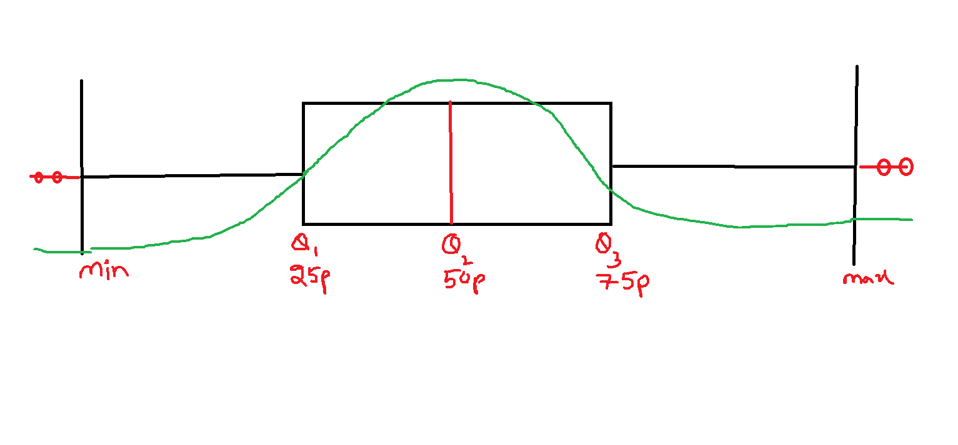

$$How to find outliers$$

$$Outliers are above Q3 and below Q1 value$$

$$Q3 person earing 5lakhs per month$$

$$Q1 person earning 10k per month$$

$$Inter quartile range:IQR$$

$$IQR=\left(Q3-Q1\right) (middile data)$$

$$Q3+ 1.5*\left(Q3-Q1\right)$$

$$Q1-1.5*\left(Q3-Q1\right)$$

$$Outliers=Q3+1.5*IQR and Q1-1.5*IQR (Mild outliers)$$

$$Q1=10k Q2=1lakh Q3=5lakh$$

$$outliers=5+1.5*\left(4.9l\right)=12.35$$

$$if a person is earning 12.35 per month or more he is a consider as outlier$$

$$outlier=10k-1.5\left(4.9l\right)=$$

$$Outliers=Q3+3*IQR and Q1-3*IQR (strong ouliers$$

$$99.7 \% data covers between 3sd$$

$$In python Box plot genertaed by default 1.5*IQR only$$

